* Aim – Program to print name and roll number of a student
* Source Code –

#include <conio.h>

#include <stdio.h>

void main()

{

printf("Name : Kunal Shah\n");

printf("Seat No : 31011223061\n");

getch();

}

* Output –

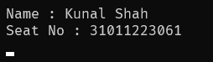

* Aim – Accept 2 float numbers from user and perform addition, subtraction, multiplication and division

of the numbers

* Source Code –

#include <conio.h>

#include <stdio.h>

void main()

{

float a, b;

printf("Enter the first number: ");

scanf("%f", &a);

printf("Enter the second number: ");

scanf("%f", &b);

printf("Addition: %f + %f = %f\n", a, b, a + b);

printf("Subtraction: %f - %f = %f\n", a, b, a - b);

printf("Multiplication: %f \* %f = %f\n", a, b, a \* b);

if (b != 0)

{

printf("Division: %f / %f = %f\n", a, b, a / b);

}

else

{

printf("Division by zero is not allowed.\n");

}

getch();

}

* Output –

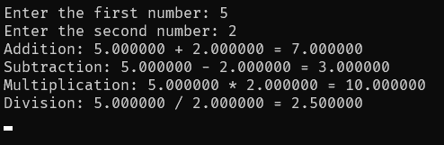

* Aim – Using ‘\*’ Symbol print ‘A’ in console windows
* Source Code –

#include <conio.h>

#include <stdio.h>

void main()

{

printf(" \* \n");

printf(" \* \* \n");

printf(" \* \* \n");

printf(" \* \* \n");

printf(" \* \* \n");

printf(" \* \* \n");

printf(" \*\*\*\*\*\*\*\*\*\*\*\*\* \n");

printf(" \* \* \n");

printf(" \* \* \n");

printf(" \* \* \n");

printf("\* \*\n");

printf("\n");

getch();

}

* Output –

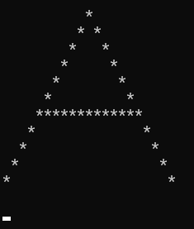

* Aim – Take two numbers as variable value from user and swap them using 3 variables
* Source Code –

#include <conio.h>

#include <stdio.h>

void main()

{

int a, b, temp;

printf("Enter the first number: ");

scanf("%d", &a);

printf("Enter the second number: ");

scanf("%d", &b);

printf("Before swapping: a = %d, b = %d\n", a, b);

temp = a;

a = b;

b = temp;

printf("After swapping: a = %d, b = %d\n", a, b);

getch();

}

* Output –

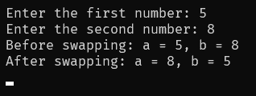

* Aim – Take two numbers as variable value from user and swap them using 2 variables
* Source Code –

#include <conio.h>

#include <stdio.h>

void main()

{ int a, b;

printf("Enter the first number: ");

scanf("%d", &a);

printf("Enter the second number: ");

scanf("%d", &b);

printf("Before swapping: a = %d, b = %d\n", a, b);

a = a + b;

b = a - b;

a = a - b;

printf("After swapping: a = %d, b = %d\n", a, b);

getch();

}

* Output –

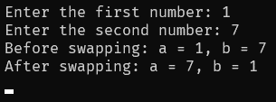

* Aim – Accept values for length, breadth and side from user and give area for rectangle and square
* Source Code –

#include <conio.h>

#include <stdio.h>

void main()

{

float length, width, side;

printf("Enter the length of the rectangle : ");

scanf("%f", &length);

printf("Enter the width of the rectangle : ");

scanf("%f", &width);

printf("Enter the side of the square : ");

scanf("%f", &side);

printf("Area of the rectangle : %f\n", length \* width);

printf("Area of the square : %f\n", side \* side);

getch();

}

* Output –

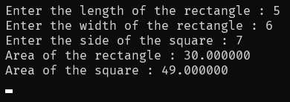

* Aim – Accept values for distance covered and time required by bike from user and display speed of the bike according to input
* Source Code –

#include <conio.h>

#include <stdio.h>

void main()

{

loat distance, time, speed;

printf("Enter the distance traveled by the bike (in km): ");

scanf("%f", &distance);

printf("Enter the time taken by the bike (in hours): ");

scanf("%f", &time);

speed = distance / time;

printf("The speed of the bike is %.2f km/h\n", speed);

getch();

}

* Output –

